**CUSTOMER SEGMENTATION AND SALES ANALYSIS REPORT**

**1. Introduction**

Objective: The primary aim of this analysis is to segment the customer base of a retail company, uncover sales trends, and deliver actionable insights to refine the sales strategy. By leveraging RFM (Recency, Frequency, Monetary) analysis alongside sales data trends, we seek to devise strategies that target key customer segments and enhance sales performance.

**2. Data Cleaning**

**Dataset Overview:** The dataset comprises sales records with columns such as Customer ID, Order Date, Product ID, Category, Region, Quantity, Unit Price, and Total Amount. Initially, it contained 363 rows and 10 columns.

**Data Preprocessing Steps:**

**Handling Missing Values:** The dataset did not have any missing values, so no imputation or data removal was required.

**Date Format Standardization:** The 'Order Date' column was standardized to the format YYYY-MM-DD.

**Duplicate Records:** There were no duplicate entries in the dataset.

**Outcome:** Post-cleaning, the dataset retains 363 rows and 10 columns, with no missing values, duplicates, and with consistent date formatting.

**3. Customer Segmentation (RFM Analysis)**

**Methodology:** Customers were categorized using RFM analysis, focusing on:

**Recency:** How recently a customer made a purchase.

**Frequency:** The frequency of their purchases.

**Monetary:** The total amount they have spent.

**Key Customer Segments:**

**High-Value Customers**: These customers make frequent purchases and spend significantly.

**At-Risk Customers:** Customers who have not purchased recently and are at risk of churning.

**New Customers:** Recently acquired customers who show potential for growth.

**Big Spender Customers**: These customers spend significantly but in the past.

**Results:**

- **34.3.86%** of the customers are High-Value Customers, contributing significantly to the company's revenue.

**- 10.7%** of the customers are At-Risk, indicating the need for re-engagement strategies.

The remaining customer base includes New Customers and other lower-value segments.

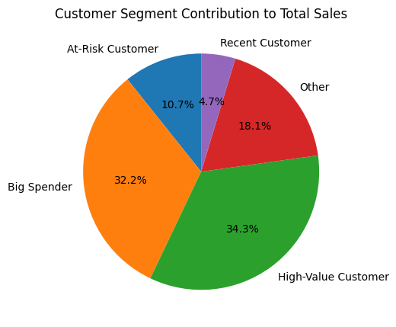

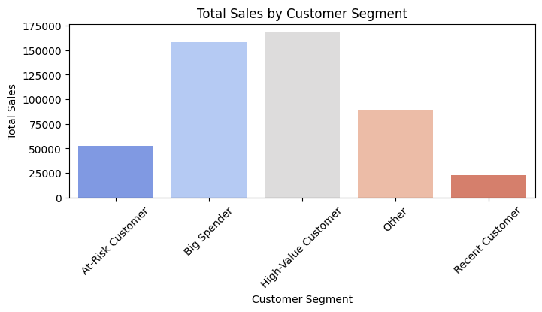

**4. Sales Trend Analysis**

**Monthly Sales** data indicates fluctuations throughout the year, with some notable peaks in certain months.

**- Highest monthly sales** in **November 2021 (28496.76)** and **January 2023 (28984.86)**  
**- Lowest monthly sales** in **February 2022 (8925.77)**

**YEARLY SALES** trends show consistent growth till 2022 but a decline after it:

**2021: 105273.01**

**2022: 236292.16**

**2023: 149733.33**  
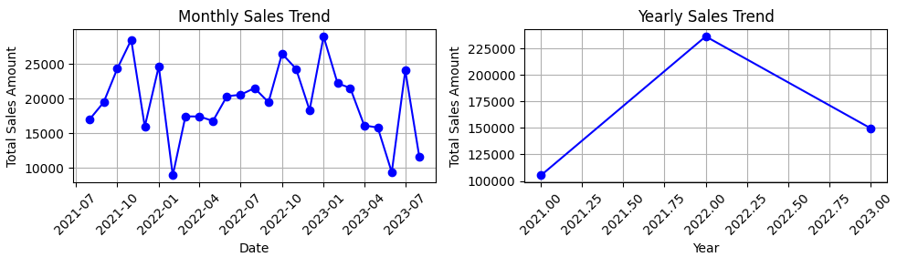

**5. Data Insights**

**Bar Chart for Top Performing Product Categories:**

The top-performing category was **Books**, contributing **23.4%** of total sales, followed closely by **Electronics**. This category was consistently in demand across various regions.

Accessories was the lowest-performing category among the top categories, contributing **17.8%** of total sales, indicating a need for strategy adjustments in this category.

**The top 5 product categories by total sales are:**

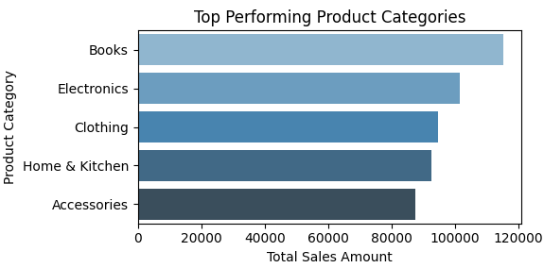

**Pie Chart for Regional Sales:**

A pie chart illustrates regional sales distribution, showing that the **East region** holds the largest share at **28.6%,** while the **West region** has the smallest share at **21.6%.**

**South: 26.2%**

**North: 23.7%**

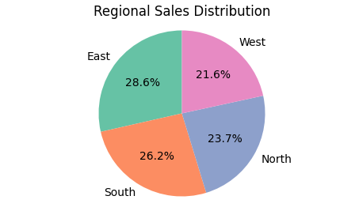

**6. Recommendations**

**Targeting High-Value Customers:**

Develop and implement loyalty programs and personalized offers to retain High-Value Customers. This segment is crucial as they contribute significantly to revenue despite being a smaller proportion of the customer base.

**Engaging At-Risk Customers:**

Initiate re-engagement campaigns such as personalized emails or special discounts to encourage repeat purchases from At-Risk Customers. This group represents a valuable opportunity for recovering potential lost sales.

**Expanding Product Categories:**

Direct marketing efforts towards high-performing categories like Books and Electronics. Consider expanding these categories with complementary products.

Evaluate customer preferences for underperforming categories like Accessories and adjust marketing strategies accordingly to boost sales.

**Optimizing Regional Sales:**

Increase inventory and tailor marketing campaigns for high-performing regions like the East to further enhance revenue.

Focus on boosting brand presence and targeted promotions in lower-performing regions like the West to unlock growth potential.

**General Sales Strategy:**

Align marketing and promotional activities with peak sales periods, such as the holiday season, to maximize revenue. Additionally, consider offering promotions during off-peak periods to stimulate sales.

**7. Conclusion**

**Summary:**

* The analysis has identified critical customer segments and sales trends, offering actionable strategies for improving customer retention, optimizing product offerings, and enhancing regional sales performance.
* Implementing these recommendations will help the retail company boost overall sales performance, strengthen customer relationships, and explore growth opportunities in underperforming areas.